# CS 340 README

## About the Project/Project Title

With the Project we are building we have implemented the CRUD operations starting with Create(C) and Read(R) and have also implemented the U and D functions. This is connected to an animal database in which clients can add new animals and also search for animals within the database. This Project has a web-based dashboard with a database connected to the Austin Animal Shelter.

## Motivation

The motivation for this project was to demonstrate our proficiency in working with a database and our skills in altering this database using Python. We also are using the MongoDB database for its ease of use within the database and how easy it is to use within our system. We also used Python for its widely available use and how well-known it is. We also used Python to connect to our database and the overall functionality within our Project.

## Getting Started

To start we import the data set and also create an index

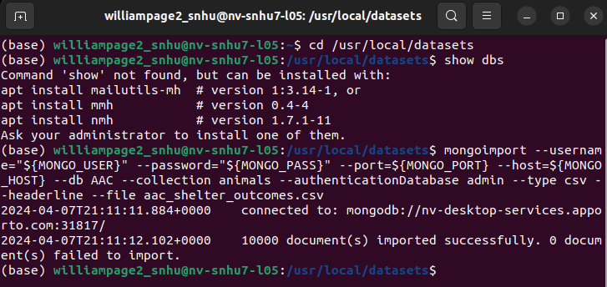

Then a user was created so the database could be authenticated with the right information and the results were pulled.

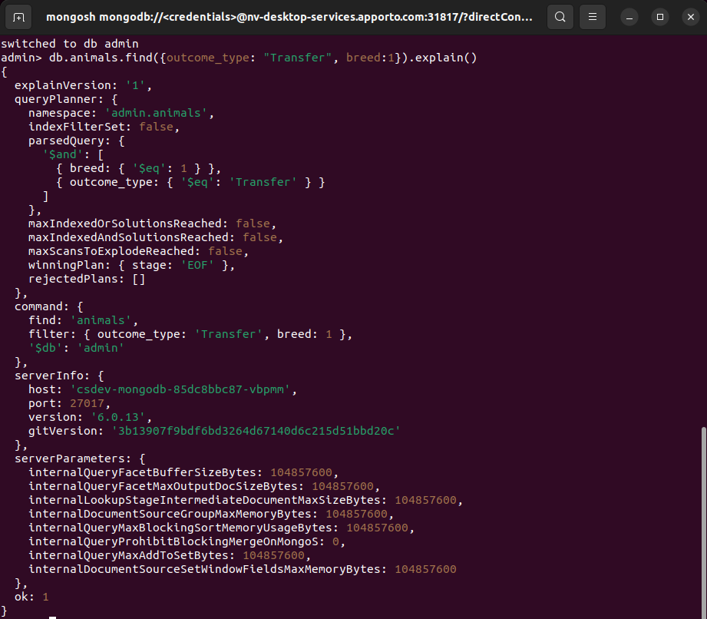

## Installation

You would need Python 3.6, Mongo DB 4.2, Pymongo 4.2, and also make a user account, all of these programs can be downloaded from their respective websites.

## Usage

### Code Example

The screenshots below provide examples of the code.

### Tests

With the help of the Test.ipynb file the data will be processed and outputted.

### Screenshots

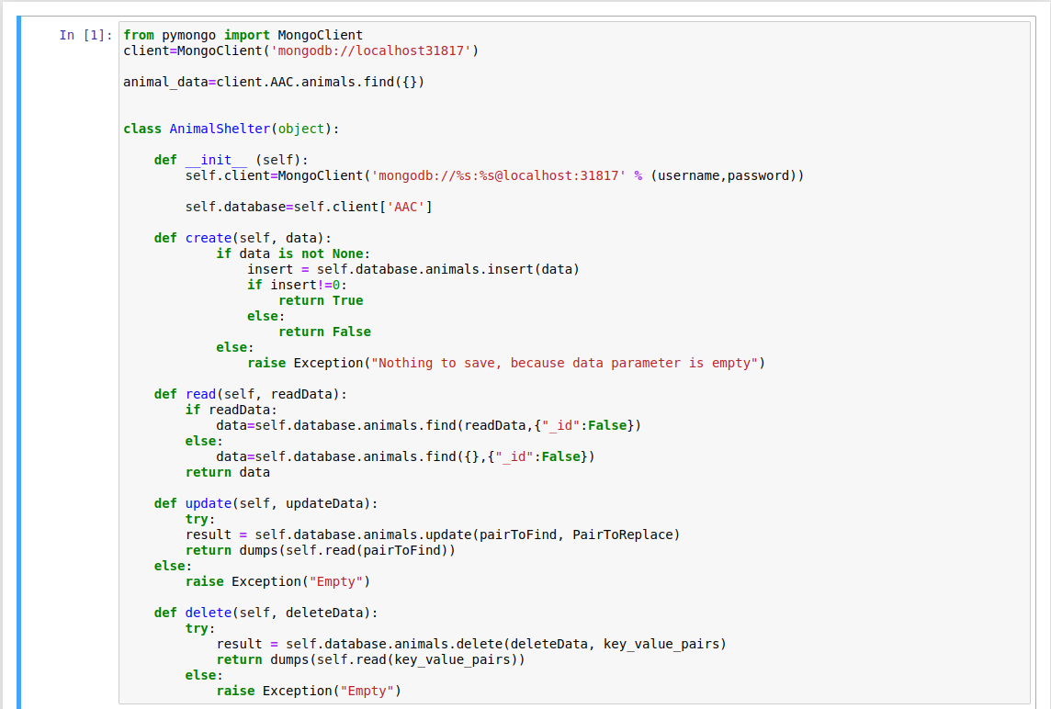

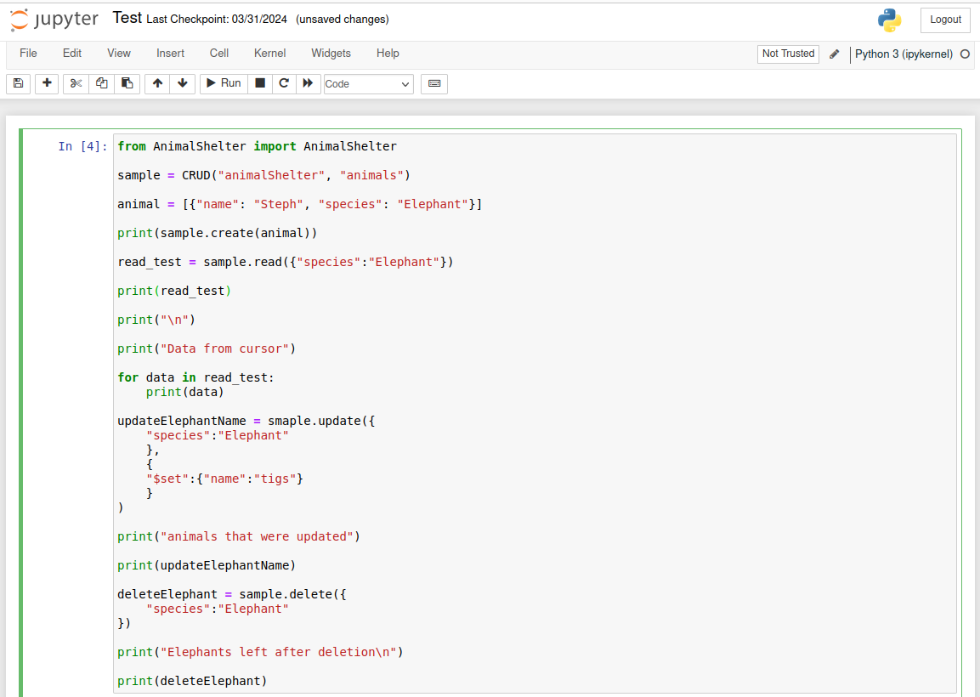

## Contact

William Page, William.page2@snhu.edu